Jenkins Task -2
1. Configure 2 slave machines in the Jenkins master.
- Jenkins Master/Controller → Jenkins Server which is already created.
- You need to create:
  - Slave/Agent 1 → Jenkins-Agent-1
  - Slave/Agent 2 → Jenkins Agent-2

Step 1: Create 2 EC2 instances
Create two additional Amazon Linux EC2 instances.
Jenkins-Agent-1 and Jenkins-Agent-2
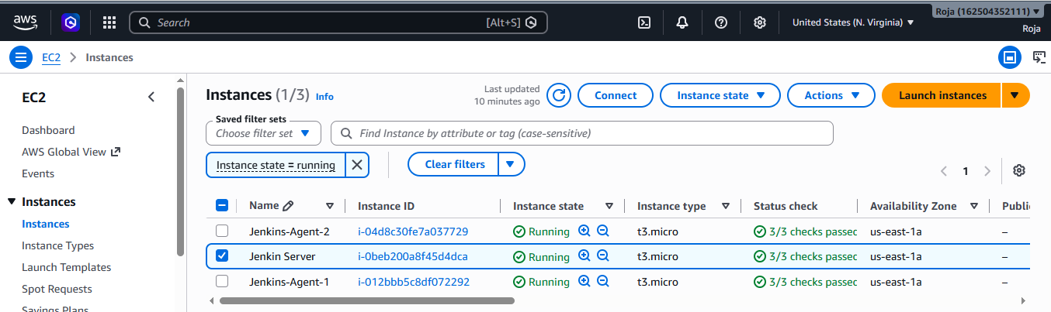

Step 2: Install Java on Agent 1 and check java version
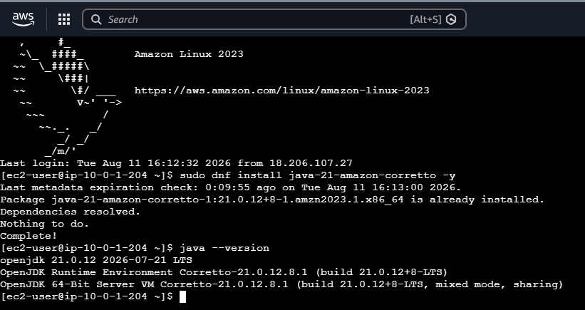

Step 3: Install Java on Agent 2 and check java version
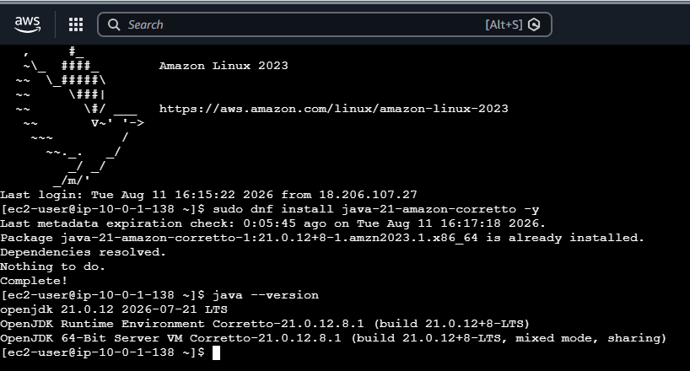
Step 4: Allow Jenkins Master to SSH to the Agents
On the Agent 1 &2 Security Group, add an inbound rule:
Type: SSH
Port: 22
Source: Jenkins Master Security Group
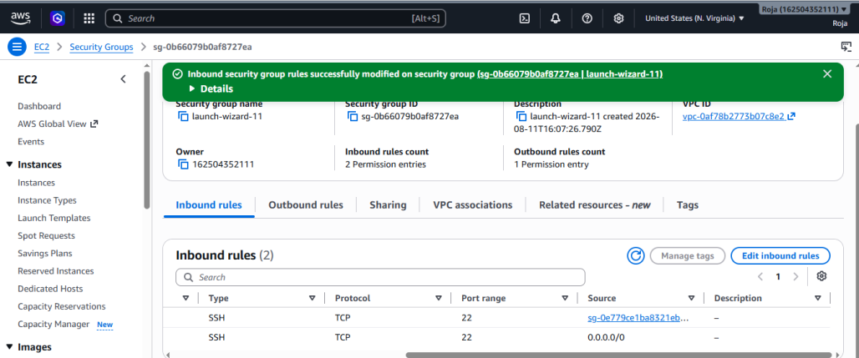
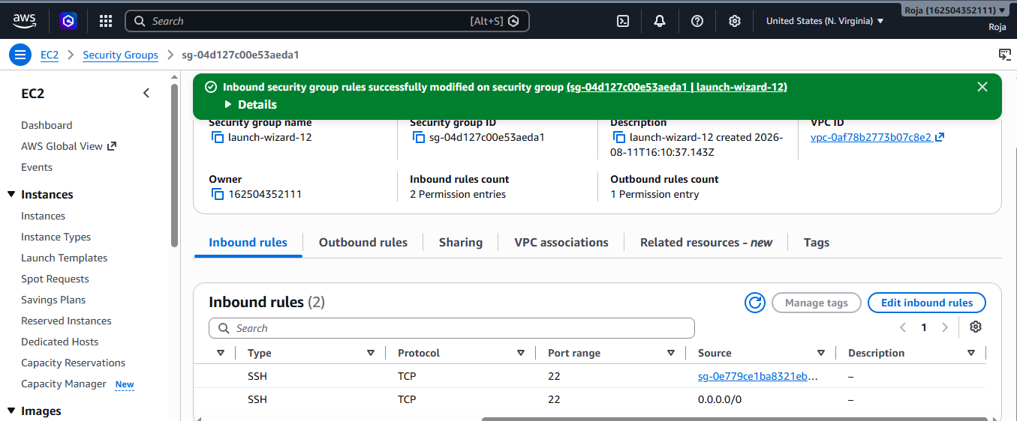

Step 5: Get Agent Private IP addresses
Go to: AWS Console → EC2 → Instances
Copy the Private IPv4 address of each agent.
Agent 1 → 10.0.1.204
Agent 2 → 10.0.1.138
You will use these IPs in Jenkins.
Step 6: Go to Jenkins Nodes
Open Jenkins: http://YOUR-JENKINS-IP:8081
Then:
Manage Jenkins
↓
Nodes

Click: New Node
Create Agent 1
Enter:
Node name:
agent-1
Select: Permanent Agent
Click: Create
Now configure:

Remote root directory
/home/ec2-user/jenkins

Labels: agent1

Usage : Select:
Only build jobs with label expressions matching this node

Launch method
Select: Launch agents via SSH
For Host, enter Agent 1's private IP: 10.0.1.204

Step 7: Test SSH from Jenkins Master
This step is very important.
SSH into your actual Jenkins master.
Find Agent 1's private IP in AWS:
Then from the Jenkins master run: ssh ec2-user@AGENT-1-PRIVATE-IP
If it asks: Are you sure you want to continue connecting?
Type: yes
You should get into Agent 1.
Then exit:
exit
Test Agent 2: ssh ec2-user@AGENT-2-PRIVATE-IP
On Jenkins Agent-1:
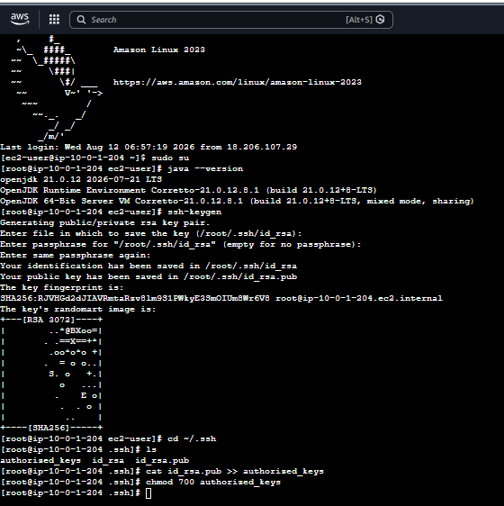

On master :
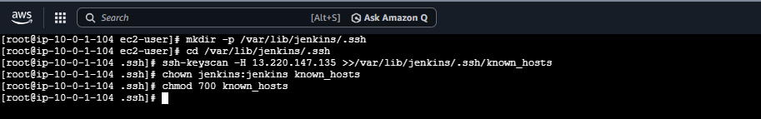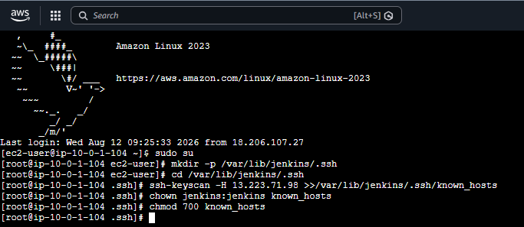
On Jenkins console:
Created Nodes for Agent-1 and Agent-2
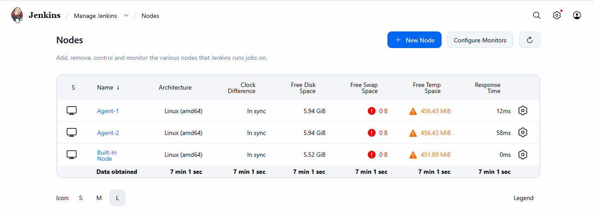

Created a job and build it successfully
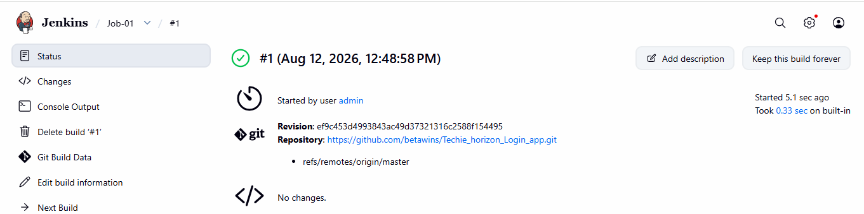

2. Configure webhooks to the Jenkins job.

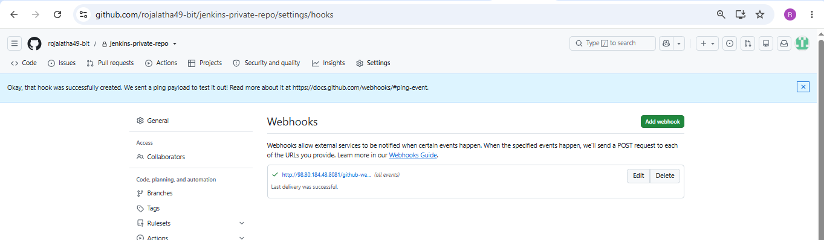

3. Configure Poll SCM and Build Periodically options in the Jenkins job.

Objective
Configure a Jenkins job with:
- Poll SCM – Jenkins checks the Git repository for code changes and triggers a build when changes are detected.

Build Periodically – Jenkins runs the job at a scheduled time, whether or not there are code changes.

Step 1: Configure Poll SCM
- Open Jenkins Dashboard.
- Select your Jenkins job.
- Click Configure.
- Scroll to Build Triggers.
- Select:
☑ Poll SCM
- In the Schedule field, enter:
* * * * *
This means Jenkins checks the Git repository approximately every minute.
- Click Save.

Test Poll SCM
Make a change to your GitHub repository:
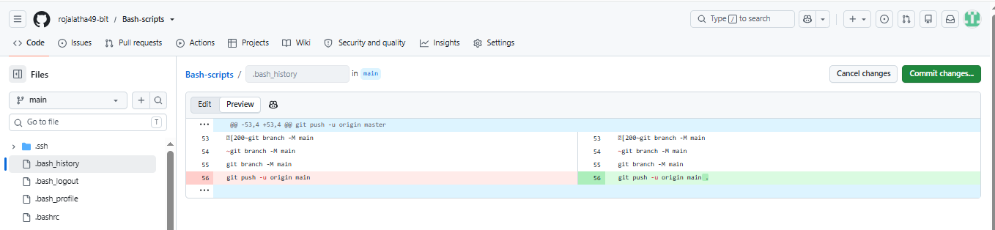
Jenkins will check the repository during its next polling interval.
If Jenkins detects a new commit, it automatically starts a build.

Step 2: Configure Build Periodically
In the same Build Triggers section, select:
☑ Build periodically
A second Schedule box will appear.
Enter:
* * * * *
This means Jenkins runs the job approximately every minute, regardless of whether there is a Git change.
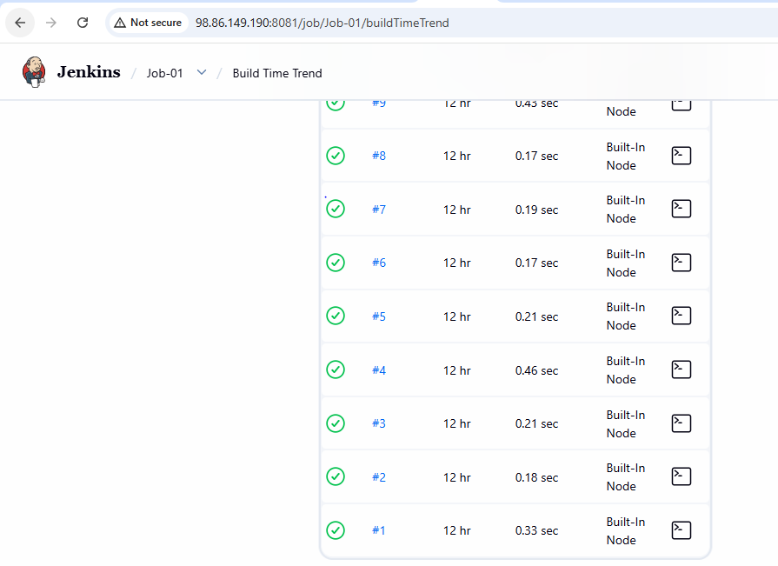

4. Take a backup of the Jenkins server using a bash-script.

Objective
Create a Bash script that backs up the important Jenkins data from the Jenkins master and stores it in a separate backup directory.
For a Jenkins server, the most important directory to back up is:
/var/lib/jenkins
It contains Jenkins jobs, configurations, plugins, credentials configuration, build information, and other Jenkins data.

Step 1: Create the backup script

On the Jenkins master:
1. Create backup file with vi editor and add a script
2. Give execute permission
3. Step 3: Run the backup script

4. Verify the backup

5. Check the contents of the backup
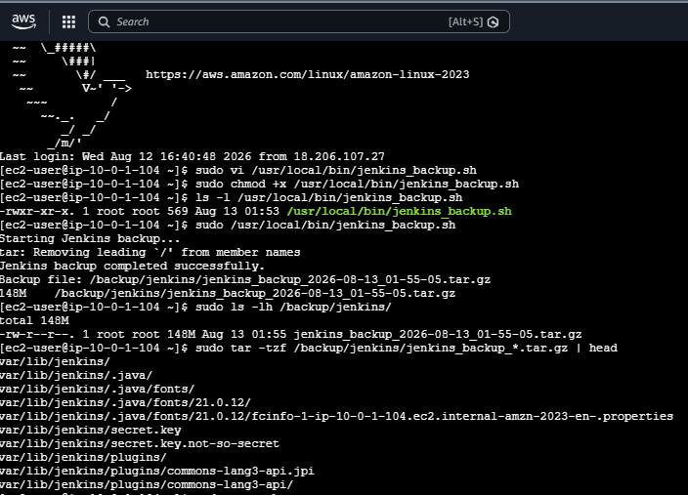
5. Take a backup of Jenkins using the Thin Backup plugin.

Objective
Use the Thin Backup plugin to create a backup of Jenkins configuration and job data.

Step 1: Install ThinBackup Plugin
- Open Jenkins.
- Go to: Manage Jenkins → Plugins
- Select the Available plugins tab.
- Search for: ThinBackup
- Select ThinBackup.
- Click Install.
- Wait for the installation to complete.
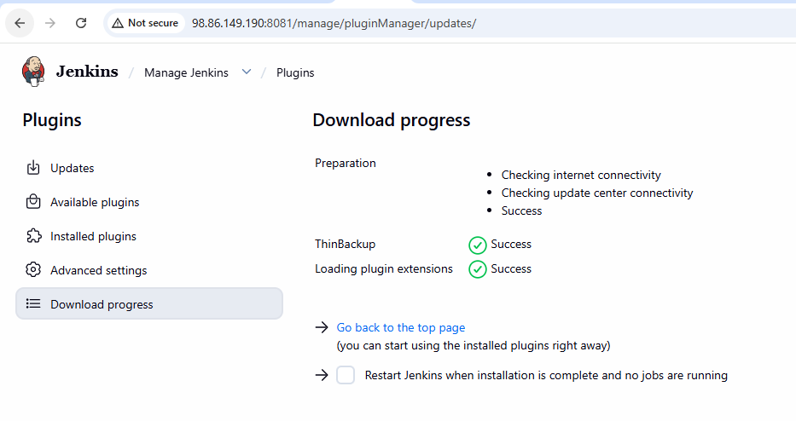
Step 2: Create a Backup Directory
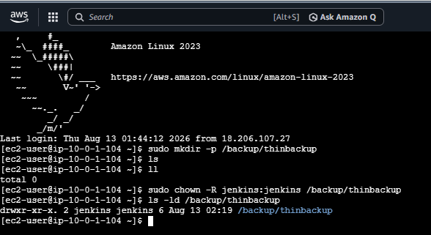

Step 5: Take a Manual Backup
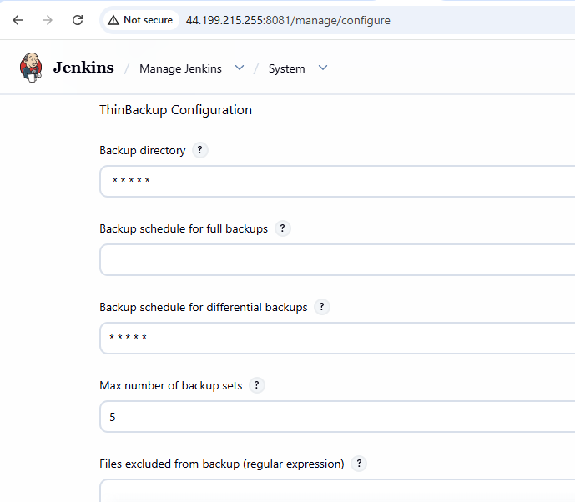
Go to: Manage Jenkins → ThinBackup
Click: Backup Now
ThinBackup will create a backup in:
/backup/thinbackup
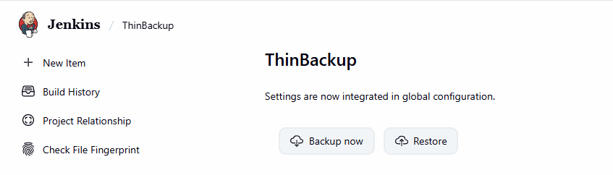

Step 6: Verify the Backup
On the Jenkins server:
sudo ls -lh /backup/thinbackup
You should see backup files/directories created by ThinBackup.
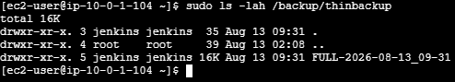

6. Set up a new Jenkins server and restore the backup taken in task
Step 1: Launch new instance
Connect to new instance
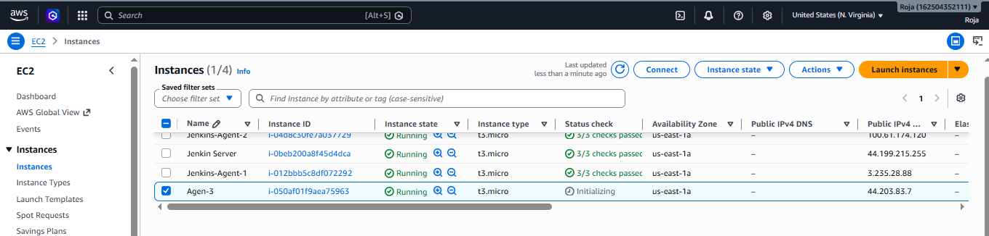

Login to Jenkins and install Thinbackup
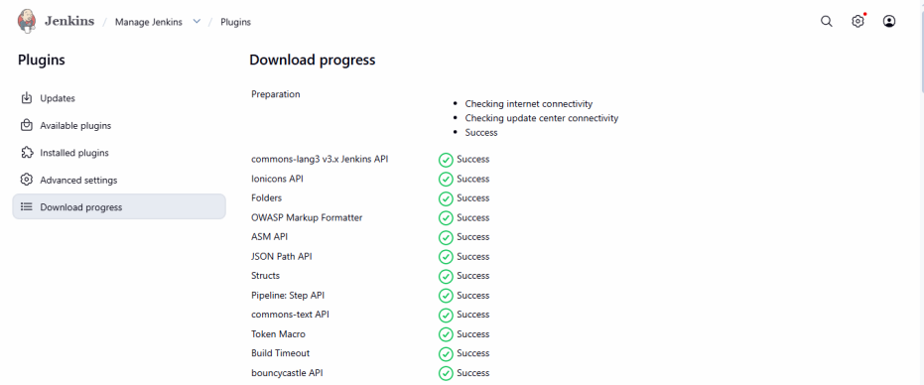

Install Java and Jenkins configure Jenkins to use port 8080

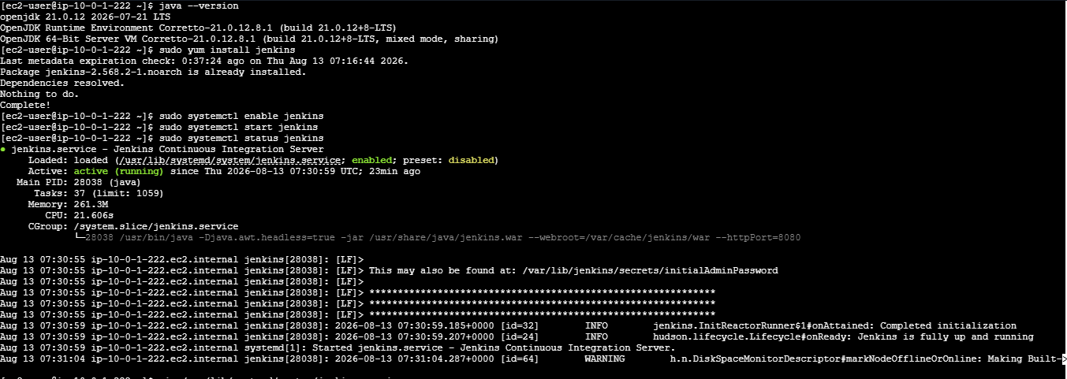
Create the backup directory
Copy Task 4 backup to the new server
Extract the backup on the new Jenkins server
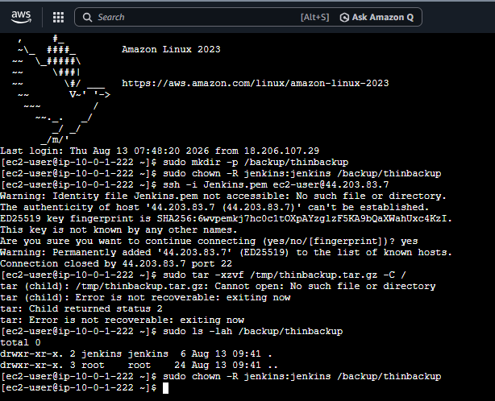

Configure ThinBackup
Go to:
Jenkins → Manage Jenkins → ThinBackup
Set the Backup directory to:
/backup/thinbackup
Click Save.

